Campus Addiction Strategy Progress Report- March 31, 2016

Project Implementation
Since the last Progress Report submitted on June 30, 2015, a complete staff of 2 full time workers and a peer worker continue to run the program.

Raised profile of the new Campus Addiction Strategy Group in the following ways; (last site visit reported was June 10, 2015)

- Health and Wellness Fair at OCADU- September 11, 2015
- Student Mental health Fair at Ryerson- September 21, 2015
- Mindfest at University of Toronto- October 7, 2015
- Art with Impact at George Brown- November 12, 2016
- Art with Impact at George Brown- December 3, 2015
- Art with Impact at OCADU- January 21, 2016
- Let’s Talk Drugs pop up 1 at OCADU- January 25, 2016
- In Service with counsellors, disability consultants and student success at George Brown- January 28, 2016
- Lets’ Talk drugs pop up 2 at OCADU- January 29, 2016
- 14 days dry event at Ryerson- February 1, 2016
- In service with Health and Wellness at OCADU- February 3, 2016
- Let’s talk workshop at OCADU- February 4, 2016
- Let’s talk workshop at Ryerson during 14 days dry event- February 11, 2016
- In service with Centre for Disability at OCADU- February 24, 2016
- In service with Academic Accommodations Support at Ryerson- March 1, 2016
- In service with counselling services at Ryerson March 10, 2016

Both posters and post cards have been created for distribution to students and posted in student arears on all Campuses. Also created outreach flyers for professionals. ( Please see pages 4,5,6,7). In addition, emails with the poster and group information have also been sent out to the TPE program at George Brown, as well as to student leaders at Ryerson, George Brown and OCADU.

Groups have been launched at each Campus as of September 22, 2015. They run on the following days;
- Tuesdays from 1:00-2:30pm- Ryerson
- Wednesdays from 2:00-3:30pm- George Brown
- Thursdays from 2:00-3:30pm- OCADU

Peer worker and staff created and facilitated a Let’s Talk Drugs pop up and workshop. This was created with the hopes of starting to talk about substance use with students on campuses on a non-stigma way. Staff had identified that a challenge for students to want to join groups on campus might be the stigma and also campus “accepting” culture of using substances as a student (see page 8-9-10 for an outline of this project). This was fully launched at OCADU with 2 pop ups and a workshop. Staffa and peer also facilitated the workshop at Ryerson during the 14 days dry event. Staff plan on launching the pop up at Ryerson and George Brown.

Measured outcomes for Students
The following outcomes have been measured as of July 1, 2016 in continuation with the annual report submitted June 30, 2015.

- As of July 1, 2015, there have been 51 students enrolled to the program (15 which continued services from last report into this report and 36 new admissions).
- 90% of students have co-written goals relating to social determinants of health. This is due to the fact that students are required to establish a minimum of 1 goal at each group which is then reviewed at the next group. Also all CSW clients are required to write goals are part of their treatment plan. The 5 identified students that did not write goals were related to the fact that they enrolled in the program and withdrew prior to goals being established (eg. Attended only 1 meeting then no contact)
- Of the 46 students that co-wrote goals, 86% met at least 2 of their goals. It is important to note that 4 students (8.5%) are new intakes within the last 14 days and therefore have not yet had the opportunity to meet a minimum of 2 goals. This means that less than 6% that were provided services did not meet this target.
- 86 % of students that we are either actively providing service to or at the time of service ending have maintained their enrollment in school. An additional 3 students (6%) of student graduated from post-secondary. 1 student is registered to go back in September 2016. Only 3 students are not enrolled in school and have not indicated at this point any detailed plans to return.

Measured Outcomes for Post-Secondary Institutions
- The referral pathways have been established between Campus Health Services and addiction support services and continue to be maintained at 100%.
- The percentage of youth that connect with the program after referral is 65%. The Staff are in the process of establishing a 1 page application to help differentiate between actual referrals and simple inquiries from students about the program. Presently as soon as staff from the campuses provide student information to LOFT staff it is seen as a referral, however after contacting students, often they have indicated that they only wanted information and not an actual referral to the program.

Steering committee
- Initial established steering committee has remained intact.
- Meeting quarterly; Met, June 25, 2015, October 23, 2015 and meeting April 1, 2016
- ACT training provided to steering Committee on June 25, 2015 by Dr. Sheri Turell
Tool Kit
- A total of 26 ACT informed modules have been created to facilitate groups with students
- These modules are all related to substance use in some way. Some examples of topics are the stages of changes, emotion regulation, and things to do in recovery, stress management and so forth.
- These modules will be included in a binder that staff can access
- Student feedback evaluation has also been created and used
Ongoing planning/ Next Steps
Next steps include;

- Running 1 all campus recovery group in the spring/ summer when school is out for most students. This will help accommodate any new members that have recently joined and prevent a break in service as well as any student still attending school in the summer.
- Focus group will be conducted with Alumni members to help ensure that future groups are informed by their feedback
- Running 1 alumni group in the spring/summer for members that have been attending longer term. Group is based using creative means for recovery such as creating a zine.
- Continue to do in services for other departments within campuses such as student association and student residences as this will reach out to those not currently accessing counselling or disability services. There is also a plan to reach out to students in secondary schools who are transiting to post-secondary in the fall.

CAMPUS RECOVERY PROGRAM

The Campus Recovery is a unique initiative offered through LOFT Community Services Transitional Age Youth Program in partnership with George Brown College, OCAD University and Ryerson University. The Campus Recovery Program aims to work with students living with mental health and substance use challenges by providing coordinated care and/or recovery oriented groups.

COORDINATED CARE
(Also known as community support work and case management)

Coordinated care workers with the Campus Recovery Program meet one to one in the community with individuals who live with mental health and/or substance use challenges and support them to achieve the goals they set for themselves. Assessment, supportive counselling, goal setting, skills teaching, system navigation, linking to resources, advocacy and monitoring are all aspects of an individualized coordinated care plan.

Criteria for eligibility:

To be eligible for a coordinated care worker prospective clients must be;
(1) Between 18 – 29 years old
(2) Attending OCAD University, George Brown College or Ryerson University
(3) Self identifies as living with mental health and/or substance use challenges

Referral procedure:

E-mail tay@loftcs.org with information on what services the client is interested in along with their;
(1) First and last name
(2) Date of birth
(3) Name of educational institution they attend
(4) An e-mail and/or phone number

CAMPUS RECOVERY GROUPS

Campus recovery groups are open groups designed for students who are using substances and feel that their use may be interfering with school, work, relationships or other domains in life. Campus Groups aim to support members in developing various life skills and coping strategies related to substance use. Topics covered in campus groups include but are not limited to;

- Value based goal setting
- Mindfulness skills
- Self-compassion and Self Soothing
- Emotion regulation (e.g., coping with stress, anxiety, and depression)
- Identifying triggers that influence substance use
- Interpersonal relationships
- Dealing with stigma and substance use

Campus Recovery Groups address substance use from a psychosocial recovery perspective acknowledging how interpersonal, intrapersonal, community and systemic issues intersect to influence each person’s unique recovery journey. Campus Recovery Groups are informed by Acceptance and Commitment Therapy (ACT), a unique and empirically supported psychological framework that utilizes aspects of acceptance and mindfulness strategies along with commitment and behavior changes to increase psychological flexibility. Psychological flexibility is concerned with changing the relationship with our experiences by turning towards what is difficult by opening up, being present and doing what matters instead of avoiding.

Campus Recovery Groups also integrate peer support. Hired peer support workers engage clients who have demonstrated notable progress in their recovery journey and who are seeking to use their lived experiences to enrich the lives of others.

Group locations and times:

Ryerson University
POD 50B
Tuesdays 1:00 pm – 2:30 pm

George Brown Casa Loma Campus
Building C, Workshop Room
Wednesdays 2:00 pm – 3:30 pm

OCAD University
2nd Floor Boardroom, Health and Wellness Centre
Thursdays 2:00 pm – 3:30 pm

Criteria for eligibility:

To be eligible for campus recovery group’s members must be;
(1) Between 18 – 29 years old
(2) Attending OCAD University, George Brown College or Ryerson University
(3) Self identifies as living with substance use challenges

Referral procedure:

E-mail tay@loftcs.org with information on what services the client is interested in along with their;
(1) First and last name
(2) Date of birth
(3) Name of educational institution they attend
(4) An e-mail and/or phone number
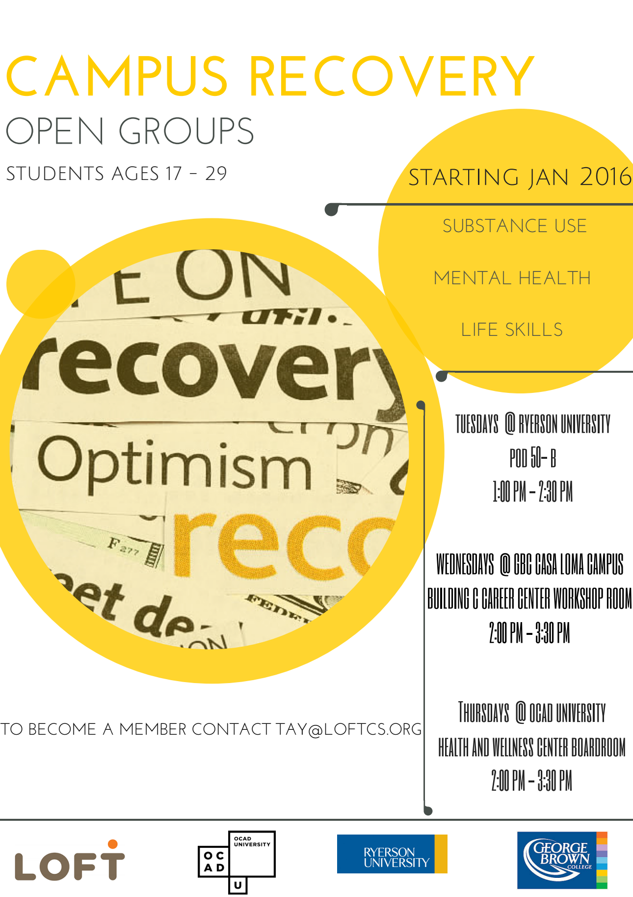

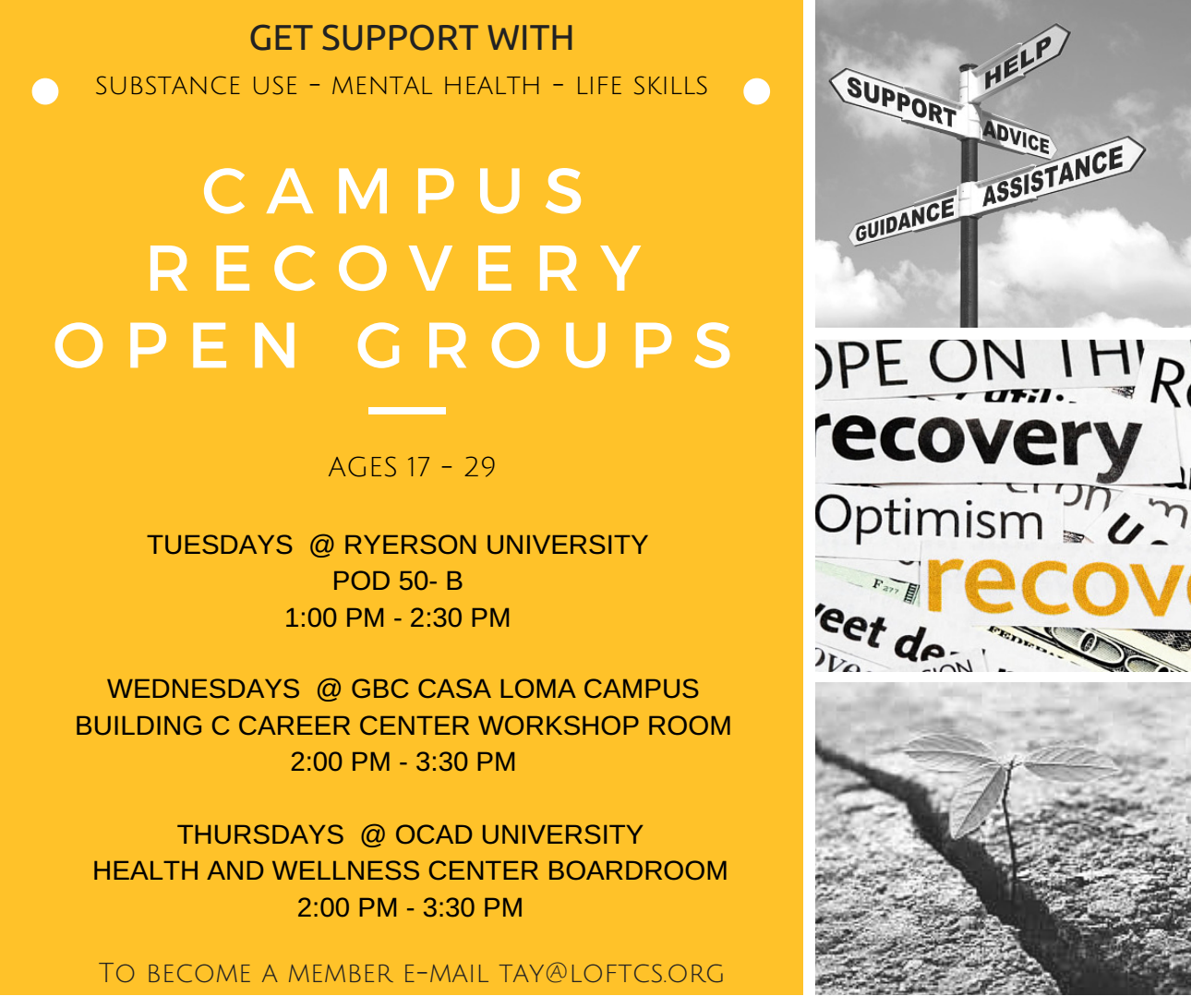

Let’s Talk Drugs- Pop up and Workshop

Campus Recovery Group’s Current Challenge

The Campus Recovery Group is for individuals who need support with substance use and mental health. One potential barrier for attendance is stigma on campus. This proposal outlines an effective outreach strategy to de-stigmatize and raise awareness around substance use and has been designed for a university audience between 19-29. This awareness campaign is approached from an anti-oppressive perspective and bears in mind how intersecting identities and experiences influence each person's relationship with substance use. Additionally, this outreach campaign is informed and lead by a Peer Support Worker whose own personal experiences with substance use, stigma, and mental health will enrich the presentation with sincerity and audience relatability.

Outreach Strategy

Get students talking about substance use, stigma, and community supports with a two-pronged outreach strategy.

Outreach Ideas
- Let’s Talk About Drugs & Drinking: General Forum/Open Workshop on stigma and substance use
- Let’s Chat About Drugs & Drinking: Pop Up LOFT Stand to speak informally about substance use, stigma, and community supports

Materials Needed

- Laptop
- LOFT Sign
- Let’s Chat Sign
- Table

1. Let’s Talk

The majority of university students have encountered substances at some time in their lives. This general discussion is geared towards students who are interested in learning more about the stigma surrounding substance use while simultaneously is an opportunity to connect with students who are thinking about seeking support for their usage. In this workshop students would be encouraged to untangle the myths and stereotypes surrounding substance use by examining cultural depictions. The discussion would be planned to stimulate university-level conversations about stigma, anti-oppression practices, and media representations.

Needed for this workshop would be a computer and screen to present examples of substances (e.g. heroin, alcohol, cocaine, etc.) and stereotypical substance users (e.g. a homeless ‘junkie,’ a college frat party, a successful businesswoman, etc.). In this activity, the facilitator would encourage the audience to share cultural stereotypes associated with the images. Another possible activity for audience members would include the facilitator asking for a handful of audience volunteers. These individuals would be instructed to stand in front of the room and one by one the facilitator would ask audience members to guess what particular substance these individuals would use entirely based on their appearance. This activity demonstrates how we’ve been conditioned by culture to make assumptions based on ethnicity, gender, age, and class. At the end of the workshop there would be a longer discussion about these kinds of assumptions and how language affects/oppresses others who are living with problematic relationships to drugs and alcohol.

The beginning and end of workshop presents an effective and innovative opportunity to alert engaged university students about the TAY’s Campus Recovery Group and additional community supports. The very end of the presentation would be an open dialogue where the audience would have about ten minutes to ask general questions about stigma, make comments about their university, and clarify their understandings of the material presented.

2. Let’s Chat

Similarly to Let’s Talk, Let’s Chat is an outreach strategy that focuses on stigma and substance use. But unlike the Workshop, the Pop Up outreach idea allows us to engage with a wider range of students and make substance use more visible. One of the unfortunate drawbacks of having an Open Discussion/Forum on substance use is it could attract individuals who are already seeking supports or having discussions about stigma. These individuals may already have the privilege of being connected to a support system and not need LOFT’s services. The Pop Up idea allows us to inject ourselves into student spaces and residences that have a high degree of traffic from the desired demographic.

Let’s Chat would only need a small table, laptop, and an attention grabbing sign to appeal to the busy and preoccupied student body. On the table the laptop would play the same presentation from the workshop on loop. At the table, the facilitator(s) would engage with students and start conversations about some of the stereotypes and barriers for individuals who are using substances while balancing their academics. This informal dialogue will be important because the very action of speaking about these issues informally in a public space disrupts the stigma surrounding substance use and university students. Because the conversation is about stigma, it will be easier to interact with students who can be connected with supports with subtle handouts with LOFT’s contact information.

Risk Assessment

Any presentation poses a variety of risks for the audience -from something as critical as a fire to as banal as a trip- but this particular workshop has some unique features that need to be considered. Since the subject of the workshop is substance use, there’s a risk that individuals might leave the presentation with an increased desire to use substances or feelings of being “triggered.” It is possible that an individual could perceive the workshop as “outing” them to their peers about their substance use or potential mental illness because we cannot guarantee confidentiality. Because people might feel triggered or “outed,” there could be the risk of audience members experiencing anxiety, depression, or suicidal ideation. Another risk in this day and age is the use of social media during or after the presentation which may include photography and contribute to additional feelings of anxiety about being “outed” as a substance user or an individual with a mental illness.

